**TASK -01**

Network Topology

Design a logical and scalable network using a **three-layer hierarchical architecture** in Cisco Packet Tracer to support efficient communication and future enhancements

**Network Layers:**

**1. Core Layer:**

* **Devices**: 2 core routers
* **Role**: High-speed backbone to connect the entire network
* **Purpose**: Provide fast and reliable routing between distribution devices

**2. Distribution Layer:**

* **Devices**: 3 intermediate switches
* **Role**: Connect access switches to the core
* **Purpose**: Policy enforcement, routing between VLANs, and redundancy

**3. Access Layer:**

* **Devices**: 4 access switches
* **Role**: Connect end-user devices (PCs, printers, etc.)
* **Purpose**: Assign VLANs, manage access and traffic from users

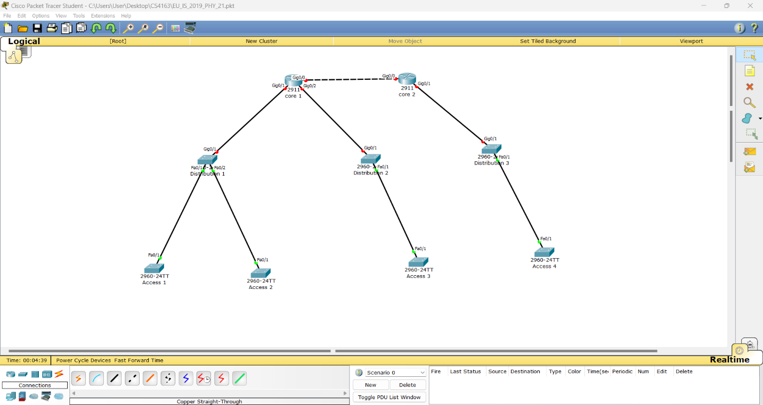

Index Number: PS2771

Registration Number: EU/IS/2019/PHY/21